**Genomics for Aleutian Islands, Gulf of Alaska, and eastern Bering Sea Pacific cod stock assessments 2022 (Sara Schaal, Wes Larson, Ingrid Spies)**

The most recent genomic analysis of Pacific cod includes a new publication that used pooled whole genome sequencing (Pool-Seq), as well as a new study conducted during 2021 and 2022 that used low coverage whole genome sequencing (lcWGS). The Pool-Seq manuscript (Spies et al. 2022) is the culmination of several years of effort, while the lcWGS is more recent and provides a more powerful approach to gather individual-based sequence data from the whole genome. Here, we focus on how the two studies contribute to our knowledge of the population structure of Pacific cod throughout Alaskan waters.

Low-coverage whole-genome sequencing analysis of 429 samples of Pacific cod from known spawning regions during spawning season indicated population structure similar to what was previously known, but with finer resolution and greater power owing to the larger number of markers. Using 1,922,927 polymorphic SNPs (Figure 1), the pattern of population structure mostly resembles isolation-by-distance, in which samples from proximate spawning areas are more genetically similar than samples from more distant areas. Isolation-by-distance was observed from western Gulf of Alaska (Kodiak and the Shumagin Islands) through Unimak Pass and the eastern Aleutian Islands. Previous studies have reported an isolation-by-distance pattern in Pacific cod using microsatellite markers (Cunningham et al. 2009 and Spies 2012) and reduced-representation sequencing (Drinan et al. 2018). Within the isolation-by-distance pattern, there were some distinct breaks in the population structure. The most significant genetic break occurs between western and eastern Gulf of Alaska (GOA) spawning samples (Figure 1), and was supported by previous research that highlighted the zona pellucida gene region (Spies et al. 2021).

A new finding from the lcWGS data was the documentation of a genetic break in samples taken from the western Bering Sea shelf, adjacent to Russia, and samples from all other regions. In other words, this study identified a new genetic group in the Bering Sea represented by samples from Russia along the western Bering Sea shelf. In addition, a subset of samples collected from Pervenets Canyon in the eastern Bering Sea appeared genetically similar to the western Bering Sea shelf group (Figure 1 bottom right where light blue points, Pervenets Canyon, mix with dark blue points, Russia). The majority of samples from the eastern Bering Sea were genetically more similar to Aleutian Islands and western Gulf of Alaska samples which was a significant deviation from the isolation-by-distance pattern found with the rest of the samples (Figure 1 center where light blue points mix with green squares, Aleutian Islands, and pink circles, western Gulf of Alaska). This result suggests an unresolved combination of isolation-by-distance. More specifically, at neutral markers Aleutian Island populations seem to follow the subtle IBD pattern documented throughout much of the western GOA. However, Aleutian Island populations are highly diverged at a few genomic regions that we believe are adaptively significant (Spies et al. 2022, Figure 2). These adaptive differences provide further support for the Aleutian Island management unit that was established as distinct from the Bering Sea in 2013.

Figure 1. Principal components analysis of 1,922,927 polymorphic SNPs from the lcWGS dataset. 

Figure 2. Regions of the genome that contain outlier loci, due to high *F*ST, a measure of genetic differentiation. Figure based on Pool-Seq data (adapted from Spies et al. 2022)

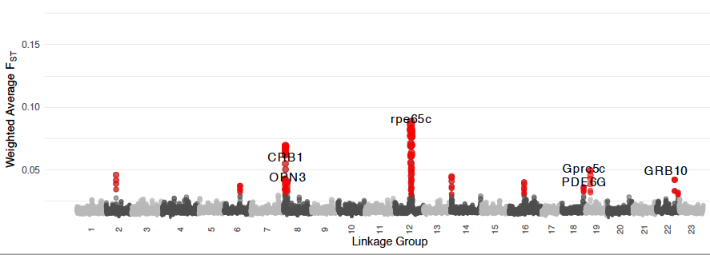

References

Bryan, D.R., McDermott, S.F., Nielsen, J.K., Fraser, D. and Rand, K.M., 2021. Seasonal migratory patterns of Pacific cod (Gadus macrocephalus) in the Aleutian Islands. *Animal Biotelemetry*, *9*(1), pp.1-18.

Cunningham, K.M., Canino, M.F., Spies, I.B. and Hauser, L., 2009. Genetic isolation by distance and localized fjord population structure in Pacific cod (Gadus macrocephalus): limited effective dispersal in the northeastern Pacific Ocean. *Canadian Journal of Fisheries and Aquatic Sciences*, *66*(1), pp.153-166.

Drinan, D.P., Gruenthal, K.M., Canino, M.F., Lowry, D., Fisher, M.C. and Hauser, L., 2018. Population assignment and local adaptation along an isolation‐by‐distance gradient in Pacific cod (Gadus macrocephalus). *Evolutionary Applications*, *11*(8), pp.1448-1464.

Fisher, M.C., Helser, T.E., Kang, S., Gwak, W., Canino, M.F. and Hauser, L., 2022. Genetic structure and dispersal in peripheral populations of a marine fish (Pacific cod, Gadus macrocephalus) and their importance for adaptation to climate change. *Ecology and evolution*, *12*(1), p.e8474.

Fu, C.H., and Fanning, L.P. 2004. Spatial considerations in the management of Atlantic cod off Nova Scotia, Canada. N. Am. J. Fish. Manage. 24: 775–784.

doi:10.1577/M03-134.1.

Taylor, B. 1997. Defining “population” to meet managment objectives for marine mammals. In Molecular genetics of marine mammals. Edited by A.E. Dizon,

S.J. Chivers, and W.F. Perrin. Society for Marine Mammology, San Francisco, Calif. pp. 49–65.

Laikre, L., Palm, S., and Ryman, N. 2005. Genetic population structure of fishes: implications for coastal zone management. Ambio, 34: 111–119. doi:10.1579/

0044-7447-34.2.111.

Spies, I., 2012. Landscape genetics reveals population subdivision in Bering Sea and Aleutian Islands Pacific cod. *Transactions of the American Fisheries Society*, *141*(6), pp.1557-1573.

Spies, I. and Punt, A.E., 2015. The utility of genetics in marine fisheries management: a simulation study based on Pacific cod off Alaska. *Canadian Journal of Fisheries and Aquatic Sciences*, *72*(9), pp.1415-1432.

Spies, I., Drinan, D.P., Petrou, E.L., Spurr, R., Tarpey, C., Hartinger, T., Larson, W. and Hauser, L., 2021. Evidence for selection and spatially distinct patterns found in a putative zona pellucida gene in Pacific cod, and implications for management. *Ecology and Evolution*, *11*(23), pp.16661-16679.

Spies, I., Tarpey, C., Kristiansen, T., Fisher, M., Rohan, S., Hauser, L. 2022. Genomic differentiation in Pacific cod using Pool-Seq. Evolutionary Applications. doi: 10.1111/eva.13488.